Real Time Online Scoreboard ReadMe

# Installation

Follow the following steps to setup the real-time online scoreboard system on your machine.

This guide will allow you to run the system locally on your machine. Other devices on your network may be able to also access the system (depending on how the network is configured).

Note that this guide is only for Windows users.

1. Obtain the system files.
   1. This can be on the USB provided.
   2. Or alternatively, you may obtain the system from GitHub:  
      <https://github.com/Hayley-Belle/R-D-AUT-Mathex-Real-Time-Online-Scoreboard/tree/Development/Code>
2. Install XAMPP
   1. XAMPP is used to run the system through your machine’s localhost.
   2. Download and run the latest installer for your machine:  
      <https://www.apachefriends.org/download.html>
   3. Once the wizard has started, navigate through the installation.
      1. Select all components that may be needed.  
         Apache, MySQL, and PHP are sufficient.
      2. Choose the installation directory.  
         C:\xampp is fine for this.  
         It is important to note the installation directory. The system files will be stored here, and some configuration files will need to be modified to run the system.
      3. Proceed with the installation.
3. Install PostgreSQL
   1. PostgreSQL is the RDBMS used by the system.
   2. Download and run the latest installer for your machine:  
      <http://www.enterprisedb.com/products/pgdownload.do#windows>
   3. Once the wizard has started, navigate through the installation.
      1. Assuming XAMPP is in C:\xampp; using the installer, install PostgreSQL in C:\xampp\pgsql\
      2. Select the PostgreSQL Server, pgAdmin 4, and command line tools when asked to select components.
      3. Use the default data directory.
      4. Set the password for the PostgreSQL superuser.  
         This is important and must be remembered so we recommend recording this password elsewhere. For the purposes of this document, we will set password to qwerty (although the actual password should be more secure).
      5. Use the default port number (5432).
      6. Proceed with the installation.
4. Start the XAMPP Control Panel program.
   1. Now that XAMPP and PostgreSQL are installed, they must be configured to communicate with each other.
   2. Use the windows search to find and start the program.
   3. Click on the config button for the Apache module (refer to figure 1).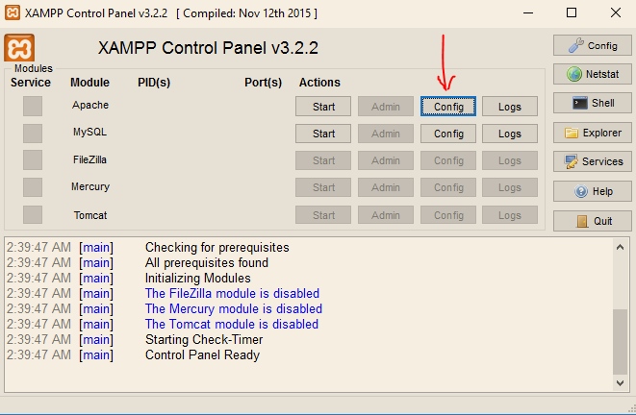

Figure 1. Accessing config files in XAMPP

* 1. Select the “php.ini” file to open it in Notepad.
  2. Once it is open, press ctrl + f to open the find feature.
  3. Find “extension=php_pdo_pgsql.dll” (without quotation marks) using the search.
  4. Delete the semi-colon at the beginning of the line.
  5. Use ctrl + f once again to find “extension=php_pgsql.dll”. In the current version of XAMPP, it is 2 lines after the “extension=php_pdo_pgsql.dll” (refer to figure 2).  
     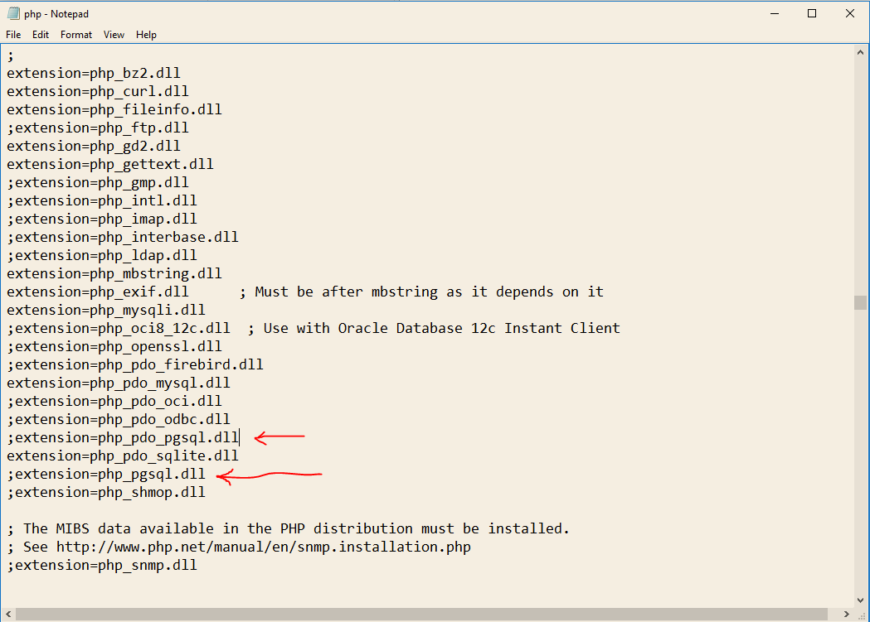

Figure 2. Editing php.ini

* 1. Delete the semi-colon at the beginning of the line.
  2. Save the document (ctrl + s).
  3. Return to the XAMPP control panel, click on the config button for Apache (figure 1), and open “httpd.conf”.
  4. Insert the following line at the bottom of the document:  
     LoadFile C:\xampp\php\libpq.dll
  5. Save and close the document.
  6. Click start for the Apache module to start the process and make localhost available.

1. Run pgAdmin
   1. Now that everything is configured for the server, we can begin setting up the database.
   2. Open the pgAdmin application. Use windows search to find it.
   3. Once it is running, on the left side, expand the servers (figure 3).  
      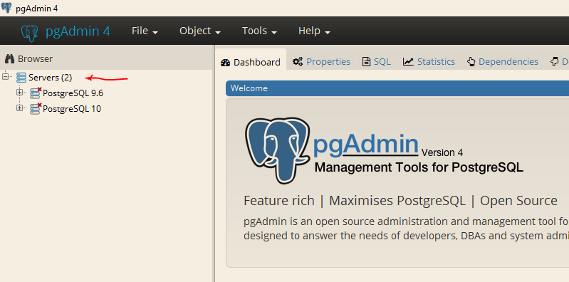

Figure 3. Selecting the correct server in pgAdmin

* 1. Select the latest version of PostgreSQL (if more than one is available).
  2. Enter the password used earlier when installing PostgreSQL (qwerty in this case).
  3. Right click on the databases, select create, and select database (figure 4).  
     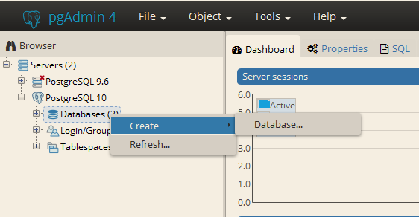

Figure 4. Creating a new database

* 1. Set the name of the database to “Mathex” and save it.
  2. Now that the database is created, expand databases, right click on the Mathex database, and select the query tool (figure 5).  
     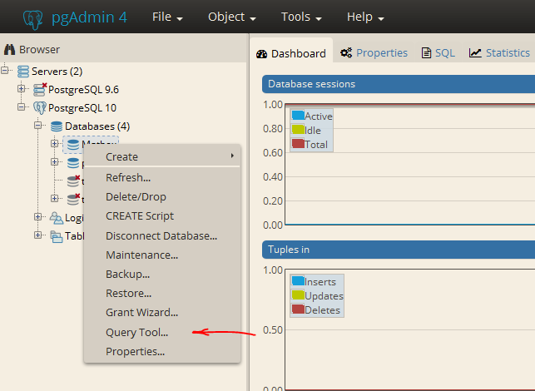

Figure 5. Opening the query tool.

* 1. Navigate to   
     <https://github.com/Hayley-Belle/R-D-AUT-Mathex-Real-Time-Online-Scoreboard/blob/Development/DomainsModel/Database_Domain_Model/setup_database.sql>  
     Copy and paste the contents of that file into the query tool and press f5.
  2. Now the database tables will be setup and an admin user will be created.   
     The credentials for that user are:  
     username = Admin  
     password = qwerty  
     We recommend deleting this user once you create other users for security purposes.

1. Add the system to the server.
   1. Now the files can be added to the server to run on localhost.
   2. Move the system files to a folder in C:\xampp\htdocs\.
   3. Open the DataBaseManagement folder inside the system files and open the ConnectionManager.php file in a text editor (Notepad).
   4. On line 10 of the file, replace the password with the password used to setup PostgreSQL (refer to figures 6 and 7). In this case, we will change it to qwerty.  
      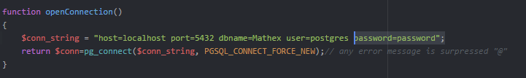

Figure 6. The existing code. Needs to be modified.

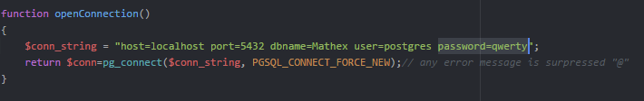

Figure 7. The modified code. Replaced password with password for PostgreSQL

* 1. Inside the htdocs folder, delete the index.php file. This will help with navigating through the localhost.

1. Run the system
   1. Open your web browser and type localhost into the address bar.
   2. Navigate to the folder in which the system files are located.
   3. Navigate to the Spectator folder.
   4. Open login.php
   5. Enter the login credentials from earlier (username = Admin, password = qwerty).
   6. Setup competitions, teams, and users as you please.

# Files

**bootstrap-4.0.0-beta-dist**Contains the local bootstrap installation. Used for style and layout of the webpages.

**JQuery**Contains the local JQuery installation. Used in the Marker files.

**node_modules**Contains the local Chart JS installation. That is the tool used to display a chart in the Leaderboard files.

**Admin**  
Contains the webpages for the Administrator domain. Login is required to access these webpages. Functionality includes adding/removing users, adding/removing teams, creating/deleting competitions, assigning teams to competitions, and starting competitions.

**Marker**  
Contains the webpages for the Marker domain. Login is required to access these webpages. Functionality includes selecting up to 2 teams to mark and marking them.

**Spectator**

Contains the webpages for spectator users. Includes functionality from both the login and leaderboard domains. Login is not required to access these webpages. Functionality includes selecting a team to track, viewing competition stats that update in real time, and being able to login.

**DataBaseManagement**  
Contains PHP files with methods in them to interact with the database. These files are used by files in the Admin, Marker, and Spectator folders.

**style**  
Contains the stylesheets (CSS files) for the webpages. Used for style and layout of the webpages. Used by files in the Admin, Marker, and Spectator files.

*For more information on the system, refer to the GitHub wiki for this project.  
<https://github.com/Hayley-Belle/R-D-AUT-Mathex-Real-Time-Online-Scoreboard/wiki>*